AJPH Twitter Chat
#First1000Days Twitter Chat – American Journal of Public Health Series Release
Overview:
To celebrate the launch of the American Journal of Public Health (AJPH) special issue, Nutrition in the First 1,000 Days, join us for a Twitter chat with editors, authors and leaders in the fields of public health, child and maternal health, as well as nutrition, to talk about the #First1000Days. The journal series focuses on opportunities to close data gaps, enhance promising programs, strengthen policies, and united around this powerful window of growth.
Host: @1000Days, @AMJPublicHealth
When: Wednesday, November 2, 12pm EST
Primary Hashtag: #First1000Days
Important Reminders:
- All tweets must include the #First1000Days hashtag to be part of the Twitter chat stream.
- Retweet questions that you are responding to, so your followers can follow the conversation even if they’re not following the chat.
- Responses should include the question number you are referencing (A1, A2, etc.)
Promo for participating partners:
- We’re excited to participate in @1000Days & @AMJPublicHealth’s #First1000Days Twitter chat highlighting their newly released journal series. Join us!

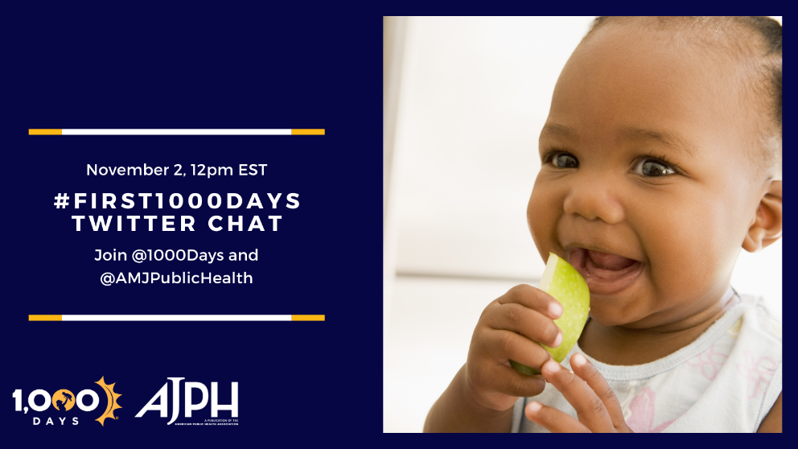

Questions:
Q1: Let’s start with the basics – define the 1,000-day window and why it is so critical for health and wellbeing. #First1000Days

Q2: The #First1000Days @AMJPublicHealth series is a milestone – it brings together papers about varied public health topics during pregnancy, birth, the postpartum period & early childhood. What was something new you learned from the series?

Q3: We know the brain grows the fastest during early childhood. Why is nutrition specifically important? #First1000Days
Q4: We've heard a lot about food security throughout the pandemic. But what is nutrition security? Is there a difference? #First1000Days
Q5: Why is now a vital time to focus on nutrition in the #First1000Days in the United States?

Q6: The #First1000Days @AMJPublicHealth series was launched on the heels of the first White House Conference on Hunger, Nutrition and Health in over 50 years. How can the series and the conference build off one another?

Q7: With this series release, where do we go from here? #First1000Days

